**Name: Karthick Mahalingam Net ID : XP9994**

**Email:** [kmahalingam2@horizon.csueastbay.edu](mailto:kmahalingam2@horizon.csueastbay.edu)

**Section 1 Execution Instructions:**

Download the zip file. Unzip to your local machine. Open Android Studio application. File-> Open and then select the project by browsing the directory. All native libraries are present within project and so no additional module is required.

Unzipped into temp directory  
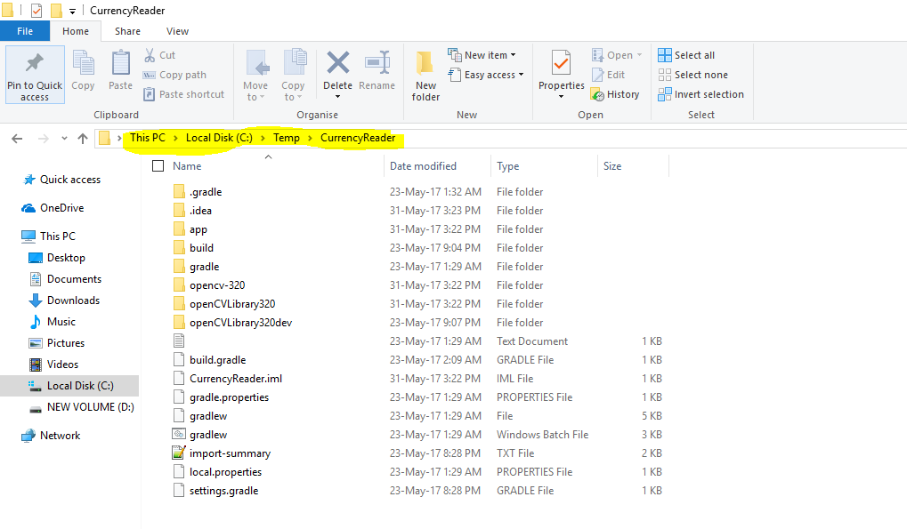

Opening the unzipped project from Android Studio  
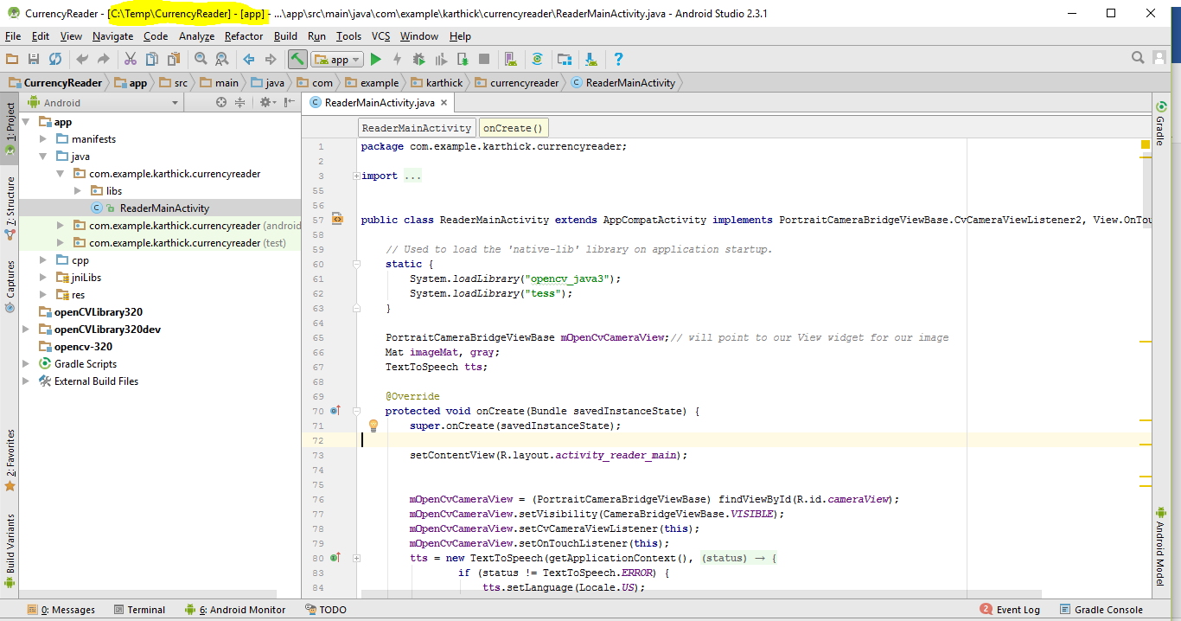

FIGURE HERE  
**screenshot 1.4 = Eclipse running the application - show screenshot of it running. If I must do something beyond simply hitting the "run" button, you need to give screenshots and step by step instructions.**

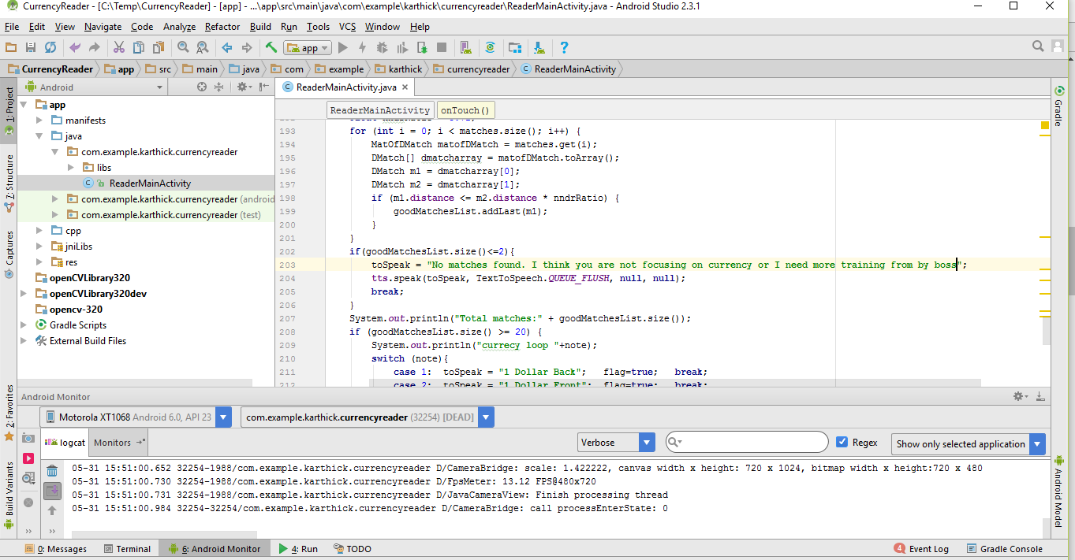

**Section 2 Code Description**

*ReaderMainActivity.java 🡪 Main program that drives the android application and performs all image processing activities and recognizes the image*

*jniLibs/armeabi-v7a 🡪 OpenCV native libraries that are called by this application using Java native call.*

**Section 3 Testing**:

**section 3.1: starting application**  
  
  
FIGURE HERE  
screenshot 3.1a= showing icon and resulting starting GUI.

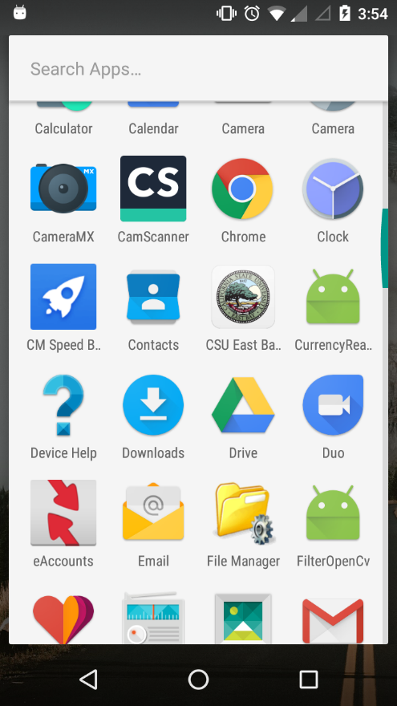

FIGURE HERE  
screenshot 3.1b= the image being viewed in your application that was just loaded.

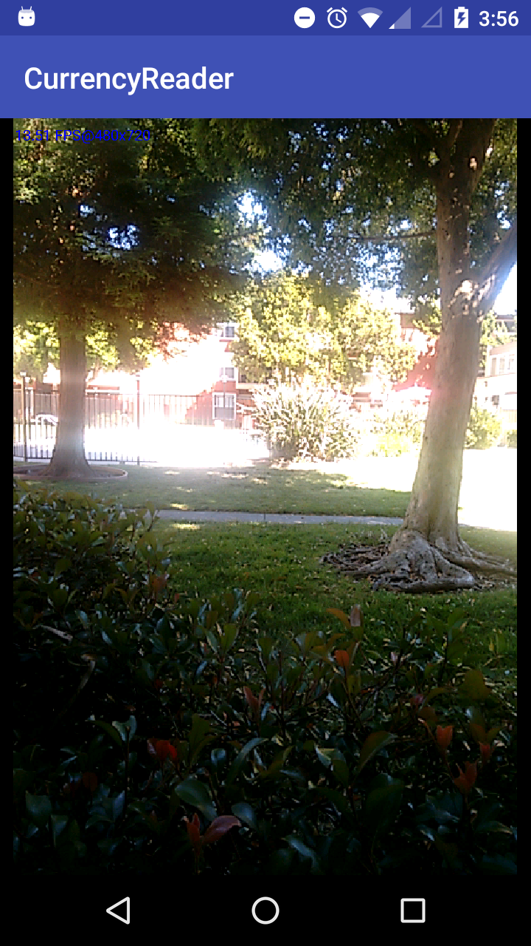

**section 3.2: use-step 1 you need to discuss your results….discuss the steps involved in using the Android application including how the image or images are taken using the Android camera and the results.**

FIGURE HERE  
screenshot 3.2a = screen shot of active image in your application you are going to process

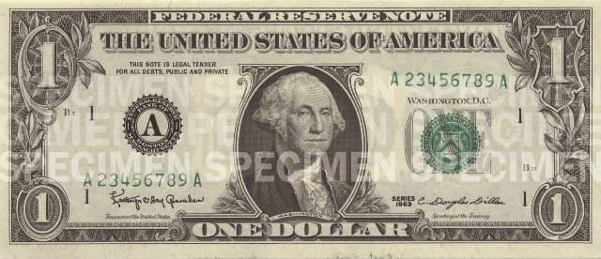

FIGURE HERE  
screenshot 3.2b = screen shot of showing results of running your program.

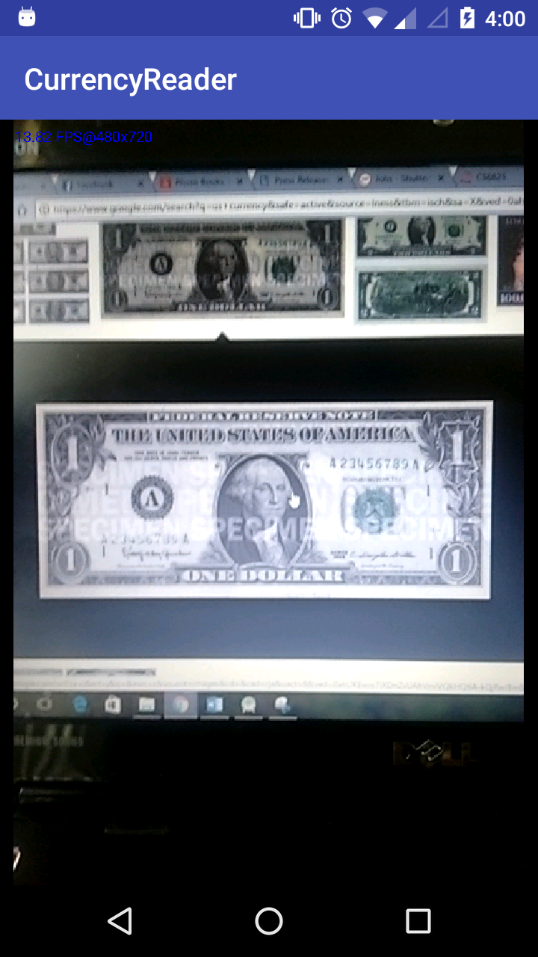

Runtime Log:

05-31 16:00:42.361 12087-12087/com.example.karthick.currencyreader I/System.out: 280 666

05-31 16:00:47.520 12087-12087/com.example.karthick.currencyreader I/System.out: Calculating good match list...

05-31 16:00:47.557 12087-12087/com.example.karthick.currencyreader I/System.out: Total matches:53

05-31 16:00:47.557 12087-12087/com.example.karthick.currencyreader I/System.out: currecy loop 2

05-31 16:00:47.557 12087-12087/com.example.karthick.currencyreader I/System.out: Object Found!!!

**Section 4 Comments**

All the modules are working successfully without any issues.

**SECTION 5** :

YouTube URL 🡪 <https://youtu.be/Rj4LQLLekCU>